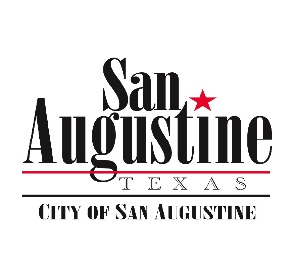**Agenda Item Attachment**

**MArch 19, 2019 City Council Meeting**

**Agenda Item: 13**

**Submitted by: City Manager**

**Reviewed by:**

**Budgeted Item: N/A**

**For Action: Yes**

**Attachments: None**

**_____**

Park Discussion

**Discussion:**

Betty Oglesbee has an update and information on the County Splash Pad Park. The Council may not be aware of this de-facto City Park or its status.

.

Other Park Issues Specific to the City.

*Note: Remember please that the funding for park improvements was contingent on receiving back monies from the EDA which was part of the Shutdown. We have really only just been funded, so we have not spent much on the parks. Much of the completed work was done from other available funds.*

Completed:

* Installation of Park Hours Signage per Council to control park use after hours
* Replacement of the locking gate at the Ball Park following sign installation
* Clearing the walking trail down the BNSF from Santé Fe Park to Mission Dolores area
* Lighting repaired at the boardwalk

Next priorities:

* Restoration of the boardwalk at the Log Cabin. Citizens have pledged donations to support this in order to preserve this central fixture if we will do it.
* Repair or more likely replace playground equipment at North Park and the Ball Park. Need estimates for equipment. Also remember we agreed with the Little League Association we would place priority on the Ball Park. Management has not had time to solicit bids for equipment since last session.
* Updates to various picnic tables, buildings, tennis & basketball facilities at the Ball Park and North Park. Repainting courts, new nets, etc.
* Grading the grassy areas at the Lewis Hotel and adjoining grounds. This is just waiting on the weather to improve.
* Removal of dead trees in park areas and clearing brush at North Park and the Ball Park.

Still to be done/looked at:

* Painting on the Caboose at Sante Fe Park
* Address a plan for Ayish Hall on the Bayou

List of Current Park Areas for Discussion:

* North Park – with tables, tennis court and playground equipment on Park Street and Harrison
* Sante Fe Park with Caboose, Ayish Hall and trail head to BNSF Trail (Often overlooked)
* The Log Cabin Lawn with Boardwalk
* The Lewis Hotel and surrounding area across from Santa Fe
* Ball Park on 21 (w/ Little League Partners)
* *Partnerships with the County on Splash Pad Park*

**Recommendation:**

Management continues to recommend we update what we have before spending new money on new parks. We will place priority on the playground equipment and surroundings. Management will make a scope for bids on replacing the equipment at North Park and the Ball Park.

**Recommended Motions:**