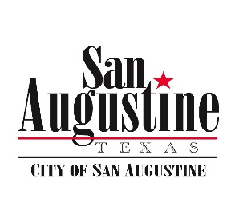**Agenda Item Attachment**

**September 17, 2019 City Council Meeting**

**Agenda Item: 10 Updated**

**Submitted by: City Manager Report**

**Reviewed by:**

**Budgeted Item: N/A**

**For Action: No**

**Attachments: Budget Status to previous month**

**_____**

**Discussion:**

1. Budget Update - See Attached
2. Items 3, 4, 5, & 6 will be discussed with KSA on a conference call the morning of the Council Meeting, so I should have an update by meeting time.
3. FEMA Road Repairs – First advertisement that we are seeking bids for the work will be published next week.
4. Main Street Capital Fund Sidewalk Grant – No remaining action by City. Plans are being finalized, and THC holds approval until plans are complete.
5. Texas CDBG Grant – No change. We are number 14 in the rankings. Agency is funding 10 this year and 10 next year, so all things being equal we will get funded in program year 2.
6. USDA Preliminary Engineering Report – KSA has a completed report ready for the USDA.
7. New cell tower on Harrison is under construction, and should be done by within the next month. Power ROW is being run at present time.
8. Due to a sales tax over payment beginning in 2014 the City will have to return an estimated $36K over the next 30 months.
9. The oil & gas lease for the city property out CR 338 was completed, and will be bringing in $27K.
10. TAMUFS Fuel Reduction will begin next week at Lewis Hotel area. Thanks to Shelby County Adult Probation for the mowing.
11. Bluestem Energy is had some initial meetings with the City and our Co-op. We have identified a near ideal site above the SO, and are presently going back and forth with Q&A.
12. Any Legal Update from City Attorney